**World Quant University**

**Professor: Tiberiu Stoica**

**Econometrics**

Nikolas Lippmann Pareschi - [nikolaslippmann@gmail.com](mailto:nikolaslippmann@gmail.com)

**Mini Project 1: Implementing Descriptive Statistics In Python and Excel**

### Problem 1:   Descriptive Statistics In Python And Excel

* + - * Download JP Morgan stock historical prices from an appropriate financial website such as Google Finance, Yahoo Finance, Quandl, CityFALCON, or another similar source.
      * Period: April 1, 2015 – June 25 2015.
      * Price considered in the analysis: Close price adjusted for dividends and splits.

Calculate in Python:

* + - 1. Average stock value
      2. Stock volatility
      3. Daily stock return

I turned on PEP8 checker on Spyder to stick to the guidelines suggested in Python 2 classes. First we declared the global variables:

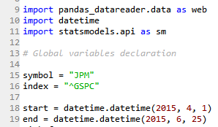

We then download the required data, did some manipulation in the data and then we finally found the requested statistics. Later we printed in the main method the statistics as requested:

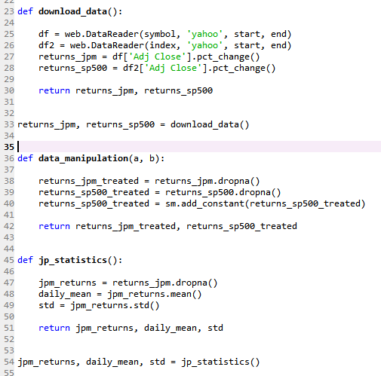

Requested statistics:

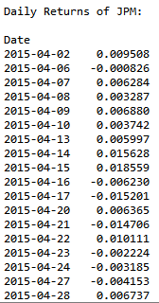

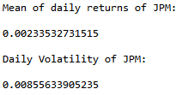

These statistics were printed throught the main function:

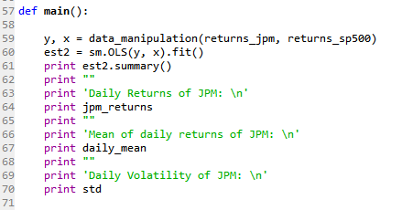

Then we did some treatment on data and applied the linear regression method using statsmodel api;

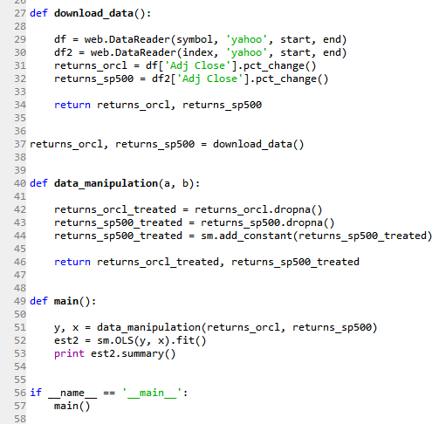

We were asked to do some calculation in excel too:

Calculate in Excel:

* + - 1. Average stock value
      2. Stock volatility

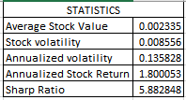

The calculations are in cell N.

* + - 1. Daily stock return

The daily stock returns were computed in column I:

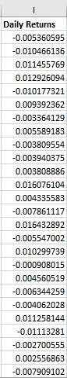

* + - 1. Show JP Morgan stock price evolution using a scatter plot
      2. Add a trendline to the graph (trendline options –linear)

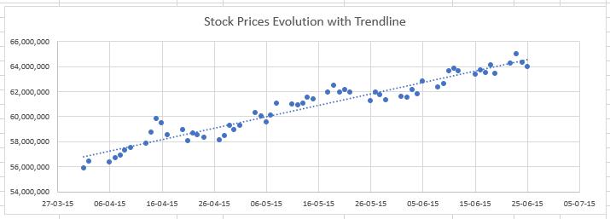

**Problem 2:  Sharpe ratio in Excel**

* + - 1. Calculate Sharpe ratio in Excel for JP Morgan stock
      2. For the period: April 1, 2015 – June 25, 2015.
      3. The risk-free interest rate is 0.1 % and is considered constant.

The sharp ratio:

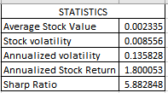

Calculated with the formula:



Which was the annualized stock return minus the risk-free rate divided by the annualized standard deviation.

**Problem 3:  Regression Analysis**

* + - 1. Implement a two-variable regression in Python.

That was done in:

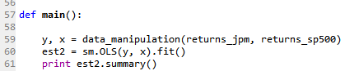

* + - 1. Explained variable: JP Morgan stock (close price)
      2. Explanatory variable: S&P500
      3. Period: April 1, 2015 – June 25 2015

Considering:

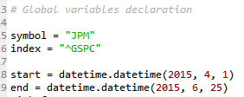

Results:

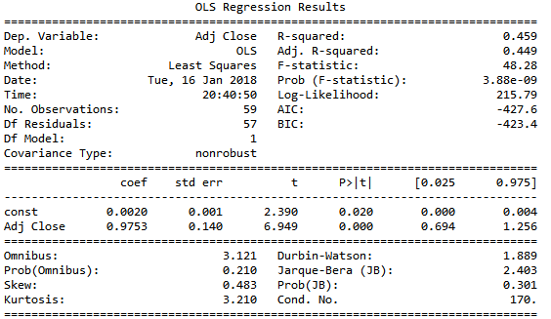

* + - 1. Implement a two-variable regression in Excel using LINEST function and Analysis ToolPak. Use the same variables as in 3.1. case.

Linest regression with Linest in excel:

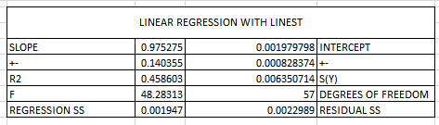

Linear Regression with Analysis Tool Pack:

